**Tool: Jupyter Notebook** 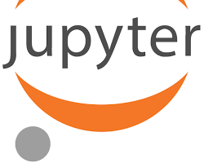

OfficialWebsite: <https://jupyter.org/try>

Purpose:

* An open-source web application that allows you to create and share documents that contain live code, equations, visualizations, and narrative text. Jupyter Notebook is a popular tool for data science exploration and experimentation.